Accessing Academic Journal Articles Online Through Maag Library
www.maag.ysu.edu

1. From the Maag Library homepage, select the “Research” tab located on the left side of the screen

2. Next, you can either select:
“Electronic Journal Center (EJC)” if you want to search for a particular topic and see search results from numerous scientific journals
“Maag Journal Finder” if you would like to search for articles from one particular journal

IMPORTANT: When you find an article that interests you, make sure: 1) the article is from one of the approved journals listed on the back of this sheet, and 2) you can download/access a FULL COPY (either a .pdf or .html version) of the article to read. Reading only the abstract (summary) will not help you fulfill your assignment requirements!

Need Help? Email John Popadak at jepopadak@ysu.edu or call him at 330-941-3679 or call 330-941-3686 and talk with a reference librarian
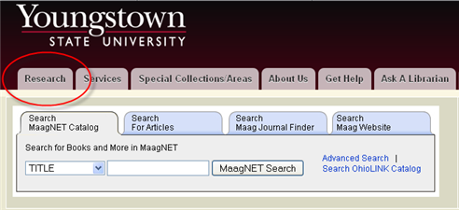

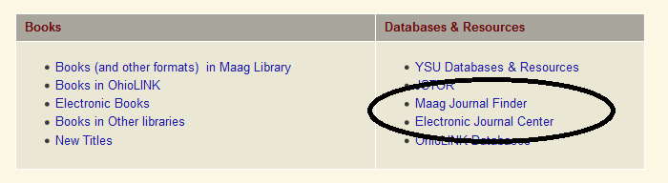

Forensic Science Related Academic Journals That Can Be Accessed Through Maag Library
Journal Title | Location | Holdings
Journal of Forensic Sciences | Maag 6th floor; EJC | 1968-2005 6th floor; 2006-present online
Forensic Science International | EJC | 1978-present
American Journal of Forensic Medicine and Pathology | Maag 6th floor | 1981-present
Forensic Science International: Genetics | EJC | 2007-present
Forensic Science, Medicine, and Pathology | EJC | 2005-present
Forensic Science Communications | On the Web | http://www.fbi.gov/about-us/lab/forensic-science-communications/fsc/archives
International Journal of Legal Medicine | EJC | 1922-1969, 1990-present
Journal of Forensic and Legal Medicine | EJC | 2007-present
Journal of Clinical Forensic Medicine | EJC | 1994-2006
Journal of Forensic Psychiatry | On the Web | 1998-2002 through EBSCO
Journal of Forensic Psychiatry and Psychology | On the Web | 2003-present through EBSCO
Forensic Toxicology | EJC | 2008-present
Journal of Toxicology | On the Web | 2009-present through EBSCO
Science and Justice | EJC | 1995-present
Computer Fraud and Security | EJC | 1995-present
Expert Evidence | EJC | 1997(#3-4)-2001(#1)
Human Immunology | EJC | 1980-present
Journal of Archaeological Science | EJC | 1974-present
Journal of Quantitative Criminology | EJC | 1985-present
Journal of Medical Entomology | EJC | 2000-2013
Medical and Veterinary Entomology | EJC, EBSCO | 2000-2004, 1998-present with 1 year embargo
Digital Investigation | EJC | 2004-present
Analytical Chemistry | EJC | 1947-present
Analytical and Bioanalytical Chemistry | EJC | 1862-1944, 1996, 2002-present
Criminal Justice and Behavior | EJC | 1974-present
Toxicology | EJC | 1973-present
Environmental Forensics | On the Web | 2000-present through EBSCO with 18 month embargo
Australian Journal of Forensic Sciences | On the Web | 2007-present through EBSCO with 18 month embargo

