CJFS 3710 Social Statistics OLS Regression Spring 2016

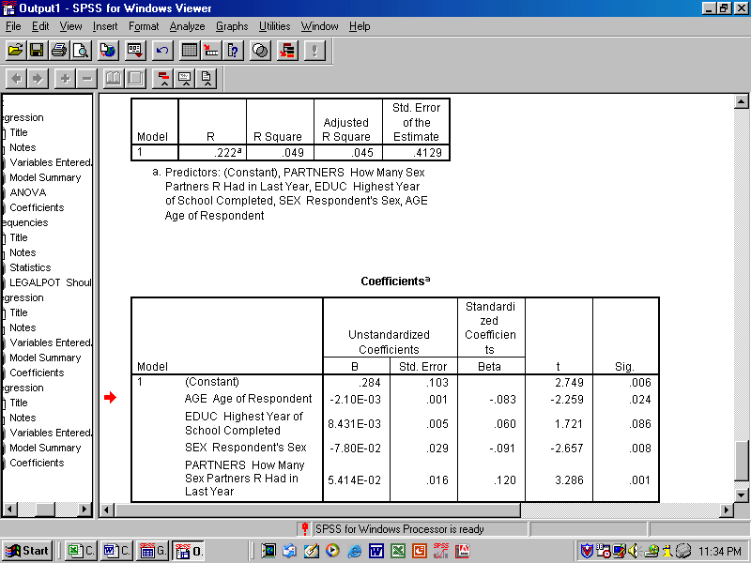
N=1,500

OLS = Ordinary Least Squares or Linear regression for short—it assumes that the DV is normally distributed as well as the IV, that the IV are not overly related to one another

Dependent Variable (DV) is “Should marijuana be legalized” (1=Yes, 0=No)

Independent Variables (IV) are:
Age: # of years old the respondent is
Educ: highest # of years the respondent has completed (2 years of college = 14)
Sex : 1=Male, 2= Female
Partners: # of sex partners the respondent had last year

Standardized Regression Coefficients allow you to compare within the equation (which is most predictive or powerful)

Unstandardized Regression Coefficients tell you for every 1 unit increase in the respective IV, how much change is there in the DV while taking into account all other IV

Adjusted R Square tells you the proportion of variance explained in the DV by all the IV in the regression equation

Sig = P Value or the proportion due to chance---the smaller Sig is, the less the var’s effect is due to something the researcher has no knowledge about—random error or chance

Sample Size needed: for each IV, you need 20 cases
CJFS 3710 Social Statistics Logistic Regression Spring 2016

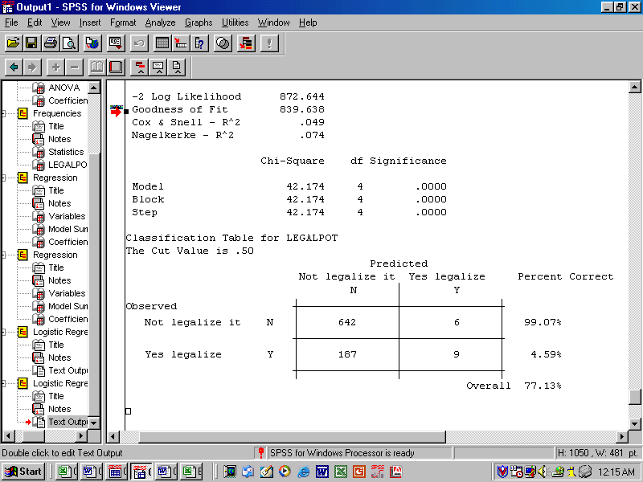

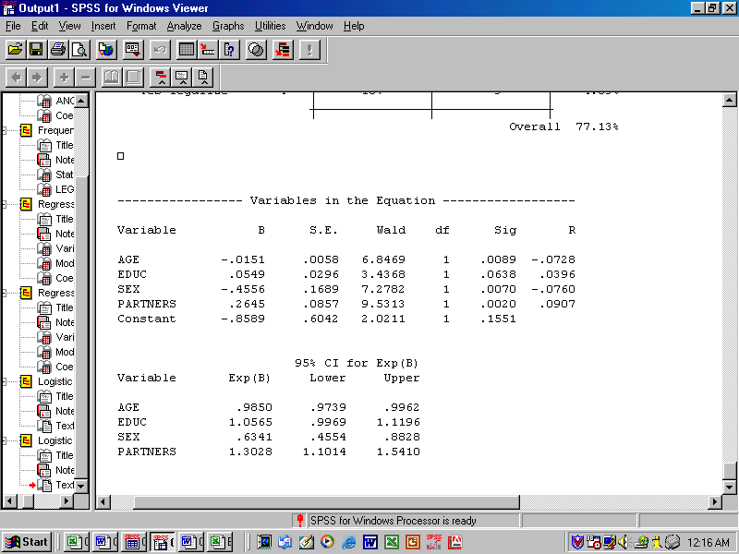
N=1,500

Logistic Regression or Nonlinear regression for short—it assumes that the DV is not normally distributed, is dichotomous, and that some of the IV can be skewed or categorical (nominal)

DV and IV are the same as in the OLS example

B = Unstandardized Regression Coefficients tell you for every 1 unit increase in the respective IV, how much change is there in the DV while taking into account all other IV

Nagelkerke's R-Square varies from 0 to 1 and is logistic’s version of R square in OLS

Exp (B) = Odds Ratio: when the 95% confidence interval (CI) around the odds ratio includes the value of 1.0 that indicates that a change in value of the IV is not associated in change in the odds of the DV assuming a given value (therefore, that IV is not considered a useful predictor)

Sig = P Value or the proportion due to chance (from the Wald statistic)

*Note for a discussion of Logistic Regression see: http://www.uwm.edu/~edari/methstat/logistic.htm#regress

