More Stats Formulas January 9, 2017
Source: http://yc.yccd.edu/student/success-center/doc/Statistical%20Formulas%20for%20Statistics%201.doc

FREQUENTLY USED FORMULAS | n = sample size; N = population size
Sample mean
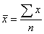
Population mean
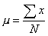
Sample standard deviation
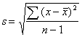
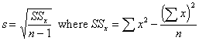
Population standard deviation
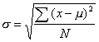

Sample mean for a frequency distribution
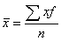
Sample standard deviation for a frequency distribution
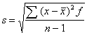
Sample coefficient of variation
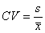
Range = Largest data value - smallest data value
Standard z value
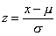
Original x value
Central limit theorem
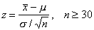

PROBABILITY FORMULAS
Probability of an event A
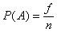
where f = frequency of occurrence of event
n = sample size
Probability of the complement of event A
P(not A) = 1 - P(A)
Multiplication rule for independent events
General multiplication rules
Addition rule for mutually exclusive events
P(A or B) = P(A) + P(B)
General addition rule
P(A or B) = P(A) + P(B) - P(A and B)
Permutation rule
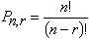
Combination rule
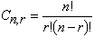
Mean of a discrete probability distribution
Standard deviation of a discrete probability distribution
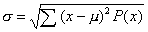

BINOMIAL DISTRIBUTION FORMULAS | where r = number of successes;  p = probability of success; q = 1 - p
Formula for a binomial probability distribution
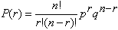
Mean for a binomial distribution
Standard deviation for a binomial distribution

CONFIDENCE INTERVALS
Confidence interval for a mean (large samples)
Confidence interval for a mean (Small samples)
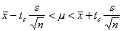
Confidence interval for a proportion (where np > 5 and nq > 5)
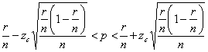

SAMPLE SIZE
Sample size for estimating means
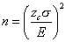
Sample size for estimating proportions
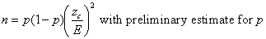
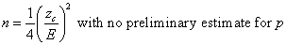

REGRESSION AND CORRELATION
In all these formulas

Least squares line
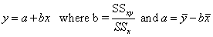
Standard error of estimate
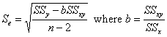
Pearson product-moment correlation coefficient
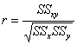
Coefficient of determination
r ²
Confidence interval for y
y_{p} - E < y < y_{p} + E where y_{p} is the predicted y value for x
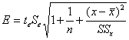
Spearman Rank correlation coefficient
